FabriScan: A clothing redistribution web application for second-hand clothes.

224664
224535

An Information Systems Project Documentation submitted to the Strathmore Institute of Management and Technology in partial fulfilment of the requirements for the award of a Diploma of Business and Information Technology

Diploma in Business Information and Technology

Strathmore Institute

Nairobi, Kenya

August 2026

Declaration
We declare that this work has not been previously submitted and approved for the award of a Diploma in Business Information and Technology from this or any other University. To the best of our knowledge and belief, the proposal contains no material previously published or written by another person except where a reference is made in the proposal itself.

Student(s)’s signature:
…………………………………. [Signature]
………………………………….. [Signature]
………………………………….………….. [Date]

APPROVAL

The Information System Project proposal of Anthony Ngari and Newell Kimanzi was reviewed and approved (for examination) by:
Supervisor’s Name: Faith Siva

Contents
Declaration i
APPROVAL i
Contents ii
Abstract iv
Chapter 1: Introduction 1
1.1 Background 1
1.2 Problem statement 2
1.3: Aim 3
1.4: Specific objectives 3
1.5: Scope 4
1.6: Justification 4
1.7: Limitations and delimitations 5
Chapter 2: Literature review 5
2.1: Introduction 5
2.2 Web-Based Accountability Systems for clothing donation Redistribution 6
2.2.1 Role-Based Access Control 6
2.2.2 Barcode Tracking 7
2.2.3 Digital vs Paper-Based Data Collection 7
2.2.4 Documented Transfer Lists 8
2.3 Challenges faced in second-hand clothes distribution and disadvantages in physical documentation 8
2.3.1 Challenges in second hand clothing reaching its destination 8
2.3.2 Limitations of Physical Documentation 9
2.3.3 Consequences of These Challenges Going Unsolved 9
2.3.4 What Has Been Done and the Remaining Gaps 9
2.4 Existing systems 10
2.4.1 WFP Building Blocks 10
2.4.2 Good360 11
2.4.3 Blockchain-Based Donations Traceability Framework 12
2.5 Conceptual Diagram 14
Chapter 3: Methodology 17
3.1: Introduction 17
3.2: Research approach 17
3.3: Research methodology 18
Requirements Engineering 19
Analysis and Design 19
System Development 20
Testing and Validation 20
3.4 Deliverables 21
4.1 Introduction 23
4.2: System requirements 23
4.2.1 Functional requirements 24
4.2.2 Non-functional requirements 27
4.3 Analysis and System design diagrams 27
4.3.1 Use case diagram 27
4.3.4 ERD Diagram 36
References 41

Abstract

Chapter 1: Introduction

1.1 Background
Around the world, many clothing donation bins that people believe are manged by private, for-profit companies (Ackerley, Takoda F. 2025). These companies deliberately make their bins look like they belong to legitimate charities, making it very hard for donors to tell the difference between a genuine and a fake collection point (KPRC 2 Click2Houston, 2024). Time and again, investigations have shown that most of the clothing dropped into these bins ends up being sold in wholesale or resale markets instead of going to people in need (Grist, 2021). Some argue that for-profit bins still serve a purpose by keeping clothing out of landfills, but this ignores the fact that donors intended their clothes to help vulnerable communities, not generate profit (ATRS Corp, 2025). In the end, charities lose vital resources and donors lose trust in the entire donation process
The people most affected by this problem are children living in orphanages and care homes, which rely almost completely on donations to cover their basic needs (Orphan Life Foundation, 2023). There are an estimated 147 million orphaned children around the world, and the need for donated clothing is far greater than what these facilities can afford on their own (Humanium, 2024). Research shows that orphaned children who grow up without enough resources face serious challenges, including emotional difficulties, poor performance at school, and struggles later in life (Onayemi & Hapunda, 2023). When donated clothing is diverted away from these children, it adds even more pressure onto facilities that are already stretched thin, leaving children without something as basic as clothes to wear (TCF Cares, 2024).
Efforts to fix the clothing bin problem have been happening for a number of years but have had limited success. In 2022, Massachusetts banned throwing away textiles, showing that governments were starting to take the issue more seriously (Mass.gov, 2022). More recently, Connecticut investigated over 120 donation bins and fined operators who were using misleading labels and placing bins without permission (Connecticut Department of Consumer Protection, 2025). However, a 2023 study found that around three quarters of donated clothing still ends up stored, shipped overseas, or thrown away rather than reaching people in need (Slow Fashion Global, 2025). Research also confirms that the fashion and donation industry still lacks the kind of clear tracking and transparency needed to make sure clothes go where they are supposed to (SCIRP, 2023). This shows that despite years of effort, there is still no proper system in place to make sure every donated item reaches its intended recipient.
What is clearly needed is a system that tracks donated clothing step by step, from the moment it is dropped off all the way to when it is confirmed as received by a trusted local organisation (Thrift Vintage Fashion, 2025). Unlike the labelling laws and recycling regulations that have been tried before, a digital tracking platform would follow each item individually and make sure it only ends up in the hands of verified organisations serving the community (Kamran et al., 2022). This tackles the actual root of the problem the lack of accountability at every handoff points rather than simply reacting after clothing has already been diverted. Studies show that donation systems without proper tracking are consistently mismanaged, and that giving all parties visibility over where donations go is the most reliable way to make sure they reach the people they were meant for (Alruwaili, 2024).

1.2 Problem statement
Missing clothes are not the only existing consequences of this problem, but also an inequality gap. The richest 10 percent of the global population earn up to 40 percent of total global income (Joint SDG Fund, 2021.),and when donated goods meant to help bridge this gap are taken for commercial use, the most vulnerable communities are left even further behind. This goes directly against SDG 10, Reduced Inequalities, which aims to make sure all people, regardless of their background or economic situation, have fair access to basic resources and services (UNOOSA, 2021). Research shows that clothing poverty is mostly managed by volunteer organisations, and when those channels are diverted there is no formal backup to replace them (Clothing Collective, 2026). Without a proper accountability system, the gap between those who have enough and those who do not will keep growing. The proposed system, a web application, that tracks donated clothing and only allows verified local organisations to collect it directly tackles this problem and supports both SDG 1 and SDG 10.
The diversion of donated clothing away from children in care is a serious global problem that affects both communities and the people trying to help them. Clothing bins placed in public spaces are increasingly run by profit-driven companies that pretend to be charities, meaning clothes meant for vulnerable children end up being sold for profit instead (Souza, 2025). Globally, around 1.3 billion people live in poverty, and half of those people are under the age of 18, making children the group most affected when donated resources never reach them. This directly goes against the first Sustainable Development Goal (SDG) of no poverty, which calls for making sure the most vulnerable people have access to basic resources including clothing. SDG 1 also specifically commits countries to tackling child poverty, recognising that poverty affects children differently and that its effects can last a lifetime (UNICEF, 2023). When donated clothing is diverted into profit-driven schemes and supply chains, it deepens the hardship of children who are already struggling, working directly against global efforts to end poverty.

1.3: Aim
To design, develop and validate a barcode-based web application focused on tracking and improving donation, accountability and redistribution of second-hand clothes.

1.4: Specific objectives
- To review existing cloth donation redistribution processes, community expectations and relevant ways to adhere to policies.
- To identify the challenges experienced when ‘pre-loved’ clothes do not arrive at their destinations and using physical documentation to record who collects clothes from the bins.
- To design a barcode-based web application, with role-based access logic and can automate transfer of records for all actors.
- To develop FabriScan’s web application using React, Node.js and a MySQL database with Excel export functionality, to ensure accountability from when clothes are collected to when they are received.
- To validate the developed FabriScan web application by testing all the modules to ensure it meets user needs.

1.5: Scope
The project, focuses on the design and development and validation of a web-based second-hand clothes redistribution system that zooms in ensuring for each item across the donation process, ultimately bringing in a functional full-stack application with a frontend held up by React Node.js backend API, and MySQL as the relational database as its primary outputs. The project progresses through four phases: requirements engineering, system design, development, and testing covering six actors, seven database tables, and five core modules (derived from donation lifecycle): deposit, collection, checking inventory, sorting and distribution. The system is assumed to operate within community locations with ample security in Nairobi, with organisations that have already been verified and approved, monthly redistribution cycles, and a stable internet connectivity available at all sites the clothing bins are located. The project is limited by a strict academic timeline (3 months) and a small testing environment .and a live community deployment. Long-term system maintenance, and scaling beyond the Nairobi environment are out of bounds for the current project. Furthermore, what is equally excluded from this phase are: mobile application development, employing hardware components, real-time bin monitoring, payment processing, physical sorting logistics and protocols involving volunteers are equally excluded from this phase, to meet project deadlines and requirements.

1.6: Justification
The clothing donation system has a well-explained accountability gap: donated clothes are being are regularly redirected for commercial resale or export before they reach the vulnerable social groups. (Lampoon Magazine, 2023) Children's homes, community centres, and church welfare programmes not only in the Nairobi but also across Kenya continue to face material deficiency, not because donated clothing is unavailable, but because no method is there to ensure it reaches them. Without intervention, this gap will persist, Kenya will fall further out of order with how its neglecting its own social welfare and trust in the redistribution chain will continue to erode, supporting further research that shows public confidence in charitable organisations is already dropping. (Greenhalgh, C., & Montgomery, P. ,2024).
The FabriScan web application addresses this by combining a physical verification method through embedded barcodes at the clothing bins at which a web application that enforces a documented proof of transfer from deposit to final distribution. The alternatives include: corporate take-back schemes and peer-to-peer platforms. None of these enforce accountability for the clothes between the donor and a verified recipient. (Threading Change, 2024)

1.7: Limitations and delimitations
The project on its own has some obstacles that could slow down development. These exist around having limited testing resources for our web-based application as it is being built by a developer team of two, lack of a stable internet connection at community collection sites is a recognised constraint across such areas (ITU,2023). These are addressed through various protocols: contacting your site representative, creates an independent check on volunteer activity and having role-based access control which regulates data modification to authorised users only. Additionally, the web application is built to perform on a low data connection, and testing is done around prioritised a consistent workflow to ensure all critical functions are validated within the available time.

Chapter 2: Literature review

2.1: Introduction
This chapter reviews existing literature relevant to the problem of donated clothing being redirected away from children in community centres and orphanages by for-profit operators of clothing collection bins. It begins by examining the business processes involved in clothing donation, including how collection bins operate, the rules and regulations that govern them, and where the current system falls short. The chapter then explores the deficiencies within the existing donation ecosystem, looking at how and why diversion occurs, what the consequences are for vulnerable children, and what efforts have been made so far to address the problem. Research from investigations, academic studies, and regulatory bodies is used throughout, drawing on global frameworks including SDG (Sustainable Development Goals) 1 and 10 to bring forward the problem within broader international development agendas. By the end of this chapter, the reader should have a clear understanding of the landscape surrounding clothing donation accountability and the specific gap this project aims to solve.

2.2 Web-Based Accountability Systems for clothing donation Redistribution
The FabriScan system is built around the need to enforce accountability at every stage of the clothing donation process; from the moment an item is deposited into a bin to the point it is confirmed as received by a verified community organisation. This section reviews the literature around the key components that make this possible: role-based access control, barcode tracking, the shift from paper-based to digital data collection, and documented transfer lists.

2.2.1 Role-Based Access Control
A core feature of the FabriScan system is that different users' donors, bin operators, administrators, and recipient organisations each have clearly defined and restricted access within the web application. This approach is known as Role-Based Access Control (RBAC), and it is widely accepted as best practice for managing user permissions within systems that require accountability and auditability (Pathlock, 2026). In an RBAC system, each user is assigned a role that determines what actions they can perform and what data they can see or change, making it easier to track who did what at every stage (Deskera, 2025). For FabriScan, this means that only authorised personnel can confirm a handoff, modify a transfer record, or approve a collection, preventing unauthorised interference at any point in the chain. In a nonprofit context, defining clear access policies and limiting data modification to administrators has been shown to prevent confusion and maintain accountability across all levels of the organisation (ButterflyMX, 2025).

2.2.2 Barcode Tracking
Each item entering the FabriScan system is assigned a unique barcode that serves as its digital identifier throughout the redistribution process. Barcode tracking systems convert physical items into scannable, traceable assets that can be followed across multiple stages of a process, reducing lost items and eliminating manual data entry errors (Kladana, 2025). For FabriScan, barcodes on the physical clothing bins identify which collector scanned a bin, at what time, and at which location turning a previously unverifiable physical action into a documented digital event. Research confirms that barcode systems provide clear timestamps and chain of custody documentation, ensuring that any discrepancies can be immediately identified and investigated (PackageX, 2025). The move toward 2D barcodes and QR codes has further enhanced traceability, allowing systems to store richer data and giving all parties more reliable, granular information (Supply & Demand Chain Executive, 2024).

2.2.3 Digital vs Paper-Based Data Collection
The FabriScan system supports both digital and paper-based documentation, recognising that not all operating environments will have consistent internet connectivity. Traditionally, community distribution organisations have relied on paper-based systems such as lists and vouchers, but these do not scale well and are vulnerable to fraud and human error (Wang et al., 2023). The shift toward digital data collection has been driven by the need for real-time updates, larger data volumes, and reduced manual errors, with research showing that digital tools significantly improve the speed, accuracy, and reach of resource distribution (Diplomatic Courier, 2024). A hybrid approach where digital records are the default, but paper receipts remain available ensures the system stays accessible regardless of infrastructure limitations (Wang et al., 2023)

2.2.4 Documented Transfer Lists
At every handoff point in the FabriScan system, a transfer record is generated that logs who handed over items, who received them, the time and location of the transfer, and the barcodes of the items involved. This mirrors established chain of custody practices in logistics and humanitarian aid, where every movement of a physical item must be documented and verifiable (Lowry Solutions, 2025). Documented transfer lists create an auditable trail that can be reviewed if any items are reported missing or diverted, ensuring responsibility is clearly assigned at every stage (Kladana, 2025). The Building Blocks system, used by 2.2 million aid recipients in 2023, demonstrates that giving all actors a unified, documented view of who is receiving what, when, and where is both achievable and transformative for accountability (Diplomatic Courier, 2024).

2.3 Challenges faced in second-hand clothes distribution and disadvantages in physical documentation
Despite the good intentions behind clothing donation initiative, second hand clothing consistently fails to reach the communities it is meant for. The task here is to examine the key challenges that cause this, the limitations of physical documentation, the consequences of these problems going unsolved, what has been done to address them, and the gaps that remain.

2.3.1 Challenges in second hand clothing reaching its destination
One of the most persistent challenges in clothing donation is that donated items are constantly diverted away from their intended receivers before they ever reach a community-based organisation. Only a fraction of items donated to charity bins are ever distributed intact within the community, with the majority being redirected into wholesale markets, exported overseas, or absorbed by for-profit operators (Reader's Digest, 2025). Studies confirm that only about 15% of clothing collected is properly repurposed, with the remaining 85% either landfilled, incinerated, or exported; rarely serving the charitable purpose donors intended (Threads Monthly, 2024). In some cases, donated second-hand clothing has even flooded local markets in developing countries, weakening indigenous textile industries in the very communities the donations were supposed to support (Reader's Digest, 2025).

2.3.2 Limitations of Physical Documentation
The second major challenge is the reliance on paper-based methods to document who collects clothing from bins and where it goes. Physically documented logs are easy to manipulate, frequently incomplete, and provide no real-time visibility of what has been collected, by whom, or where items have been taken (Wang et al., 2023). Research confirms that organisations operating without digital accountability systems face significantly higher risks of mismanagement, as there is no reliable audit trail to verify that collections were carried out by authorised individuals (WJARR, 2026). Without a digital record linking each collection to a specific verified person, it is practically impossible to identify where in the chain a diversion occurred.

2.3.3 Consequences of These Challenges Going Unsolved
When pre-loved clothing fails to reach its destination and physical documentation remains the only record of collection activity, the consequences are felt most sharply by children in orphanages and care homes who depend on those donations for basic needs (Orphan Life Foundation, 2023). At a broader level, the failure of the donation system erodes donor trust, with research showing that donors are significantly less likely to continue giving when they cannot verify their contributions reached the right people (Charity Navigator, 2023). The organisations themselves also suffer, losing credibility and donor support when accountability failures come to light (WJARR, 2026).

2.3.4 What Has Been Done and the Remaining Gaps
Some jurisdictions have introduced bin labelling regulations and operator registration requirements, while blockchain-based tracking systems have been made to create transparent distribution records (Alruwaili, 2024). However, blockchain technology remains largely inaccessible to small community organisations due to its technical complexity and high implementation costs (FundsforNGOs, 2025). The gap that remains is the absence of a practical, affordable digital system that tracks the clothes from bin deposit to confirmed receipt at a verified organisation. The FabriScan system is designed specifically to fill this gap, replacing unreliable physical documentation with a simple but robust digital chain of custody accessible to community-level operators.

2.4 Existing systems
Various systems have been developed globally to address the problem of accountability in redistribution and donation of garments. While no previously established system resembles FabriScan’s specific focus on community-level clothing redistribution through physical clothing bins, each offers evidence of what can be achieved on the technical level, where current solutions fall brief, and what gaps remain unaddressed. The three systems reviewed here are: WFP (World Food Programme), Building Blocks, Good360, and the Blockchain-Based Donations Traceability (BBDT) Framework, proposed by Kamran, were considered and selected because each represents a distinct approach to the same core problem: ensuring donated goods reach verified recipients through a documented, accountable process. Each analysis shows how the system works; the tools and techniques supporting them, its strengths, and the gaps it leaves compared to FabriScan’s objectives.

2.4.1 WFP Building Blocks
The World Food Programme's (WFP) Building Blocks is the world's largest blockchain-based humanitarian distribution platform, providing the closest existing demonstration of multi-actor, documented chain-of-custody accountability for goods distribution (WFP Innovation, 2024). Launched as a 100-person plot in Pakistan in 2016, the system then expanded to Jordan, Bangladesh, Ukraine, Syria, and Palestine, with 159 organizations using the platform across three countries by 2025 (UN Innovation Network, 2026). Building Blocks operates as a private blockchain network, co-owned and co-governed by participating humanitarian organizations, with each beneficiary assigned an anonymous identifier linked to biometric data held by the UNHCR (United Nations High Commissioner for Refugees), ensuring that sensitive personal information is never stored on the chain (CoinGeek, 2025). Every distribution event whether food, cash, or essential goods is recorded as a fixed block, meaning no participating party can alter a record after it is confirmed, enforcing accountability at every handoff (Kamran et al., 2022). By 2025, the platform had helped avoid 288 million in unintended duplicate assistance and coordinated support for 4.8 million households, validating that a documented chain of custody for humanitarian goods is both technically feasible and operationally transformative at scale (WFP Innovation, 2024). The principle Building Blocks establishes is that all actors in a distribution chain should share a neutral record of every transaction which directly informs the accountability model FabriScan applies to clothing redistribution.

Despite its scale, Building Blocks has significant limitations concerning FabriScan's community-level objectives. The platform is designed for cash transfers and food distribution within established humanitarian crisis settings and provides no mechanism for tracking individual physical items such as clothing garments through a community redistribution chain (Centre for a Digital Future, 2024). It requires technical expertise in distributed systems to deploy and govern, placing it beyond the capacity of community organizations such as children's homes or church welfare groups operating clothing redistribution programmes (Dissanayake & Pal, 2023). The system depends on connectivity and devices at every distribution point, which is an unreliable assumption in community settings where infrastructure is inconsistent TheBiometric authentication, is impractical for our clothing donation system.

2.4.2 Good360
Good360 is a US-based product philanthropy platform that operates as a managed intermediary between corporate donors and vetted nonprofit organizations, redistributing surplus goods — including clothing and apparel — to communities in need (Good360, 2025). The platform connects major retail and manufacturing partners including Amazon, Walmart, Nike, and CVS Health with a network of over 100,000 verified nonprofits, matching surplus donations to organizations based on need, proximity, and logistical capacity (Good360, 2025). Good360 enforces accountability through mandatory no-resale agreements with every participating nonprofit, supplemented by monitoring and, for high-risk product categories, controls such as debranding or serialization to prevent commercial diversion (Good360, 2025). In 2025, the platform integrated Salesforce's Agentforce AI to automate matching between surplus goods and disaster-affected nonprofits, reducing manual coordination time and improving distribution speed (Salesforce, 2025). A Power BI dashboard, developed with Queryon, provides real-time reporting of donation flows and multi-year impact tracking, generating detailed financial reports for corporate partners that demonstrate how goods were distributed (Good360, 2025). Since its founding, Good360 has distributed over USD 25 billion in donated goods, confirming that a platform-mediated, accountability-enforced model for goods redistribution is viable and scalable (Good360, 2025).

Despite its demonstrated effectiveness at corporate scale, Good360 has structural limitations that make it unsuitable as a model for community-level clothing redistribution in Kenya. The platform operates exclusively at a corporate entry point — individual donations, community donation drives, and physical collection bins are entirely outside its scope, meaning it does not address the diversion problem that Tabak targets (Good360, 2025). Participating nonprofit organizations must hold 501(c)(3) tax-exempt status, a US-specific regulatory classification that excludes community-level organizations across sub-Saharan Africa (Good360, 2025). Organizations are also required to maintain commercial storage facilities within 50 miles of a donor site and provide their own transport, placing significant logistical and financial burdens on smaller groups that are the primary recipients Tabak serves (Good360, 2025). The platform tracks goods at the shipment level rather than at the individual item level, meaning a single garment cannot be followed through the redistribution chain from deposit to final recipient. Good360 also operates in the reverse direction to FabriScan. It redistributes corporate surplus stock outward to organizations, rather than tracking community-donated clothing from a collection bin to a verified local recipient. The accountability gap Good360 leaves diversion of physical items at the community collection point, and this is what precisely what FabriScan is being built to address.

2.4.3 Blockchain-Based Donations Traceability Framework
The Blockchain-Based Donations Traceability (BBDT) Framework, proposed by Kamran et al. (2022), is a peer-reviewed academic system designed to enable all parties in a charitable donation process to trace the full movement of donations from contributor to confirmed recipient. The system is built on a public-permissioned Ethereum blockchain, in which every transaction is recorded as an immutable block on a distributed ledger that is visible and verifiable by all participating parties simultaneously (Kamran et al., 2022). The framework's architecture is documented through sequence diagrams and algorithmic rules for each handoff stage, providing a structured, reproducible design that can be adapted across different donation contexts (Kamran et al., 2022). Using a hybrid qualitative approach, the framework demonstrated shows improved traceability over conventional charity donation systems, with donors able to verify in real time that their contributions were progressing toward the intended recipient (Kamran et al., 2022). The system directly validates FabriScan’s core proposition: that the absence of a verifiable, end-to-end record linking a donor to a confirmed recipient is a solvable technical problem, not an inherent limitation of the donation process.

As an academic framework, the BBDT system has practical limitations that prevent its direct adoption at a community level. Deployment on the Ethereum blockchain requires expertise in smart contract development and distributed systems architecture, placing it well beyond the technical and financial capacity of community organizations managing clothing redistribution programmes in Kenya (Dissanayake & Pal, 2023). The framework was designed for monetary and financial donations and does not include any mechanism for tracking the physical movement of individual items such as clothing garments from a collection point through sorting to a recipient's hands (Kamran et al., 2022). Blockchain's core property of being stable, which is effective for financial accountability, creates operational challenges in physical redistribution contexts where human data entry errors require correction after the fact. The system also assumes consistent internet connectivity and computational resources at all nodes, which cannot be guaranteed in community settings across sub-Saharan Africa (Wang et al., 2023). No evidence of real-world community deployment is presented in the paper, limiting the framework to a proof-of-concept rather than a field-tested solution. FabriScan responds to these gaps by delivering a lightweight, web-based chain-of-custody system.

2.5 Conceptual Diagram
The proposed FabriScan system is designed around the Input-Process-Output-Storage (IPOS) model, with clearly defined system boundaries and six distinct actor roles: Donor, Volunteer Collector, Site Contact, Sorting Team, Organization Representative, and Administrator, each interacting with the system through a dedicated interface module (Pressman & Maxim, 2020). This structure reflects the software design principle of abstraction, ensuring that each actor sees only the functions and data relevant to their role, reducing complexity, and the risk of unauthorized interference. The five processing modules: Deposit, Collection, Inventory, Distribution, and Audit, are designed as functionally independent units, each with a single, well-defined responsibility and communicating with adjacent modules only through defined API endpoints, consistent with principles of modularity and low coupling (Pressman & Maxim, 2020).

At the input layer, three primary data entry points exist: the Donor deposits an item and logs it via the web interface, triggering the generation of a unique barcode; the Volunteer Collector logs a bin collection event, which enters a pending state until the Site Contact provides digital approval; and the Organization Representative confirms receipt of distributed items, closing the chain of custody at the final handoff. All processed events have been persisted to a MySQL relational database structured around seven tables: Users, Bins, Deposits, Collections, Inventory, Organizations, and Distributions, with foreign key relationships enforcing integrity and timestamps supporting the full audit trail.

At the output layer, the system produces four categories of output: deposit, confirmation, receipts for Donors; collection approval in form of notifications for Site Contacts and Volunteers; distribution confirmation records for Organization Representatives; and an audit trail, that can only accessed by the developers, reports that aim at accountability, accessible to the Administrator through direct database queries without a dedicated UI. The Administrator module sits across all layers of the system, with read access to all records and write access for user management, bin management, and organization approval; granting oversight without disrupting the operational workflows of other actors. This design ensures that the system enforces a closed, verifiable loop from the point of donation to the point of confirmed receipt, with no stage in the redistribution process left undocumented or unaccountable.

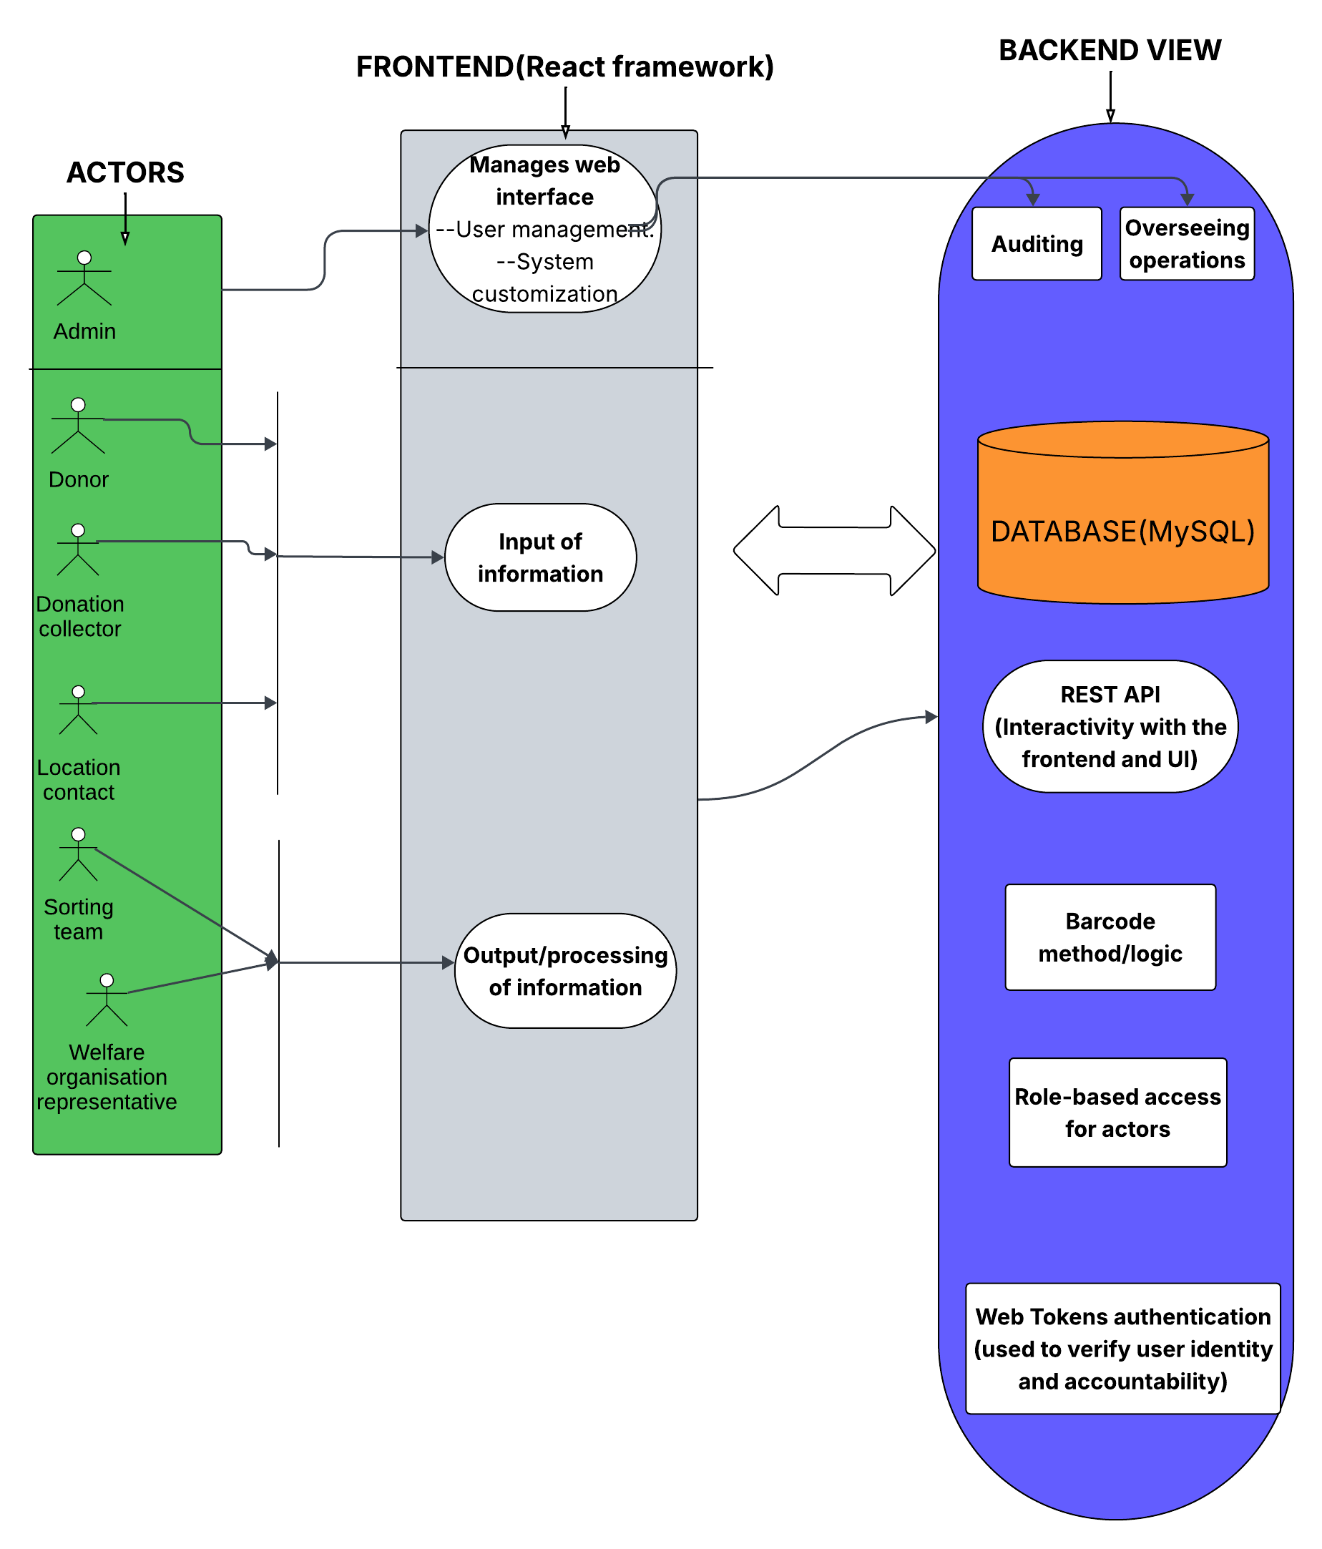

Chapter 3: Methodology

3.1: Introduction
Chapter 3 of this report details the research and development of the FabriScan system. First, the chapter discusses the use of Object-Oriented Analysis and Design as the development philosophy for the project. This method is better suited for a system with a variety of actors and modules than Structured Systems Analysis and Design. Following this, the software development approach for the project is discussed, with Agile methods being selected. The sprint-based approach of the Scrum methodology is best suited to the academic project timeline and the system’s modular design. Each sprint in the project is described in detail, outlining the specific work that will be done in each sprint to develop the FabriScan system. Finally, the chapter discusses the deliverables for the project. These include the written documents, modules for the FabriScan system, the user roles within the system, the security mechanisms, and the reports that the system will generate. Together, these sections outline the research and development of the FabriScan system, moving from problem to solution.

3.2: Research approach
In software engineering and development, there are two methodologies used to plan, build, and organize systems: SSAD (Structured Systems and Design) and OOAD (Object-Oriented design). The main difference between SSAD (Structured Systems Analysis and Design) and OOAD (Object-Oriented Analysis and Design) is how they break down a system. SSAD treats data and processes separately, focusing on handling tasks in a step-by step basis while OOAD focuses on defining the system structure and relationships between singular, self-contained objects. After extensive research, the chosen methodology for FabriScan is OOAD. The system is built around six clearly defined actors, each having distinct roles, attributes, and responsibilities whose interactions drive every stage of the donation and redistribution chain; the actor roles maps directly onto OOAD's use case and the methodology allows for the use of UML diagrams which adequately represent the system in a way that the SSAD method could not. OOAD's cumulative and iterative nature further supports this decision, allowing continuous refinement of each module deposit, collection, inventory, distribution, and audit based on feedback, without requiring the complete detailing that SSAD's process, of a sequential nature, requires. (Liu, 2022). The software stack chosen supports this decision: React's component model, Node.js's architecture, and MySQL's database relational structure. Critically, OOAD's compatibility with Agile iterative delivery is essential within the project's sub-three-month timeline, enabling each module to be designed, built, and tested in independent cycles rather than through the rigid sequential dependencies that characterise SSAD's structural approach. (Koç, 2021)

3.3: Research methodology
The FabriScan system was built with the Agile methodology. Agile is iterative and adaptive. Teams can adapt and modify the project scope as they learn and gather user feedback. Within Agile methodology, Scrum has been chosen as the software approach for FabriScan. It organises development into short cycles known as sprints; each one of them lasting two to four weeks. Scrum is particularly suited to FabriScan’s working timeline; rather than specifying the entire system before building anything, Scrum allows the core modules: deposit, collection, inventory, distribution, and audit to be developed and tested as independent, prioritised sprint goals within structured steps (Ekechi, 2024).

Additionally, the Scrum team for this project are two developers they both hold roles of both Product Owner and Development Team, with academic supervision providing sprint review and retrospective checkpoints in the role of Scrum Master. Waterfall is removed as an option because it is direct and requirements must be fully defined before design begins and design must be complete before development starts doesn’t match with the iterative, actor-modelling nature of OOAD and rigid for a limited academic timeline.

Requirements Engineering
Sprint 0 involves the foundational phase of Scrum, where the scope of analysis is properly investigated, and all the requirements are brought out, documented and arranged into a good product layover before any development takes place. For FabriScan, this phase begins with a structured review of the problem .Specifically, the accountability gap in community clothing donation to ensure that the system's requirements are grounded in the real-world problem rather than assumed. Requirements will be gathered through structured interviews conducted with at least one representative from each of the six actor groups: a potential donor, a volunteer collector, a site contact from a community location such as a church or community centre, a sorting team member, an organisation representative from a verified recipient body, and a system admin. The interviews will use open-ended questions designed to uncover each person’s expected relationships with the system, their data needs, workflow expectations, and any environmental constraints such as device availability or connectivity limitations. Functional scope includes barcode scanning and generation at deposit, site contact and sign-off at distribution. They will be documented as user stories. System constraints includes: system response time, data security, enforcing role-based access and being compatible with low-bandwidth connections.

Analysis and Design
Sprint 1 is dedicated entirely to analysis and design, producing the full suite of OOAD artefacts required to guide the subsequent development sprints without writing any production code. In line with the OOAD methodology adopted in Section 3.2, the following UML diagrams will be produced: a use case diagram mapping all six actors — Donor, Volunteer Collector, Site Contact, Sorting Team, Organisation Representative, and Administrator — to the system functions they initiate and interact with; class diagrams modelling the domain entities including User, Bin, Deposit, Collection, Inventory, Organisation, and Distribution, along with their attributes, methods, and relationships; and sequence diagrams tracing the step-by-step actor-system interactions for the three most critical workflows — the item deposit flow, the collection approval flow, and the distribution sign-off flow (Koç, H., Erdoğan, 2021). An Entity Relationship Diagram (ERD) will be produced to model the relationships between the seven database tables, with foreign key constraints defined to enforce referential integrity, and a full database schema will be used as the layout for MySQL implementation. Wireframes will be designed for each of the six role-based interfaces: donor deposit view, volunteer collection form, site contact approval screen, sorting team inventory view, organisation representative distribution view, and administrator panel. All UML diagrams and the ERD will be produced in draw.io and wireframes will be produced in Figma, This sprint concludes with a review in which every artefact is mapped back to the product backlog user stories to confirm that all functional requirements are accounted for in the design before Sprint 2 begins.

System Development
This is the development phase, in which the designed solution is built across three focused sprints, each delivering a tested and functional set of modules. FabriScan is developed as a web-based application because a web platform requires no installation, is accessible from any internet-connected device, and can serve all six user roles through a single, role-differentiated interface. The frontend is built using React.js, chosen for its component-based architecture, which maps directly onto FabriScan’s design: each role-specific interface is developed as a reusable, independently testable React component, and the component hierarchy reflects the actor hierarchy established in the use case diagram produced in Sprint 1. The backend is implemented using Node.js with the Express framework, REST API handles all requests from the React frontend, enforces role-based access control on every API endpoint, and communicates with the MySQL database; Node.js is selected because its JavaScript runtime allows the same language to be used across the full stack. Allows for validation of logic between frontend and backend. MySQL is selected as the database management system. The development environment is Visual Studio Code, selected for its extensive JavaScript, React, and Node.js extension support, and its integration with Git. Sprint 2 delivers the authentication system, user management, and deposit module, sprint 3 delivers the collection, site contact approval, and inventory modules and sprint 4 delivers the distribution module, organisation management system, and administrator panel.

Testing and Validation
This sprint is dedicated to verifying and validating the completed system against the requirements established in Sprint 0, using a structured, multi-layered testing approach to confirm that the chain of custody is correctly enforced across all user roles and handoff points. Unit testing is conducted on individual React components and Node.js controller functions using the Jest testing framework, verifying that each isolated unit of code performs its specified function. Integration testing is performed using Postman to verify that all REST API backend interact correctly with the MySQL database across all six roles, confirming that data flows accurately between the frontend and backend and that no handoff can be completed without the required approvals Functional testing (5 modules): deposit, collection, inventory, distribution, and audit against their corresponding user stories from the product backlog, confirming that the system behaves as specified under realistic usage conditions, including edge cases such as a second deposit to the same bin and a distribution to an organisation that has not yet been approved by the administrator. UAT (User Acceptance Testing) is conducted with representative participants from at least three of the six actor groups (donor, site contact, and the organisation representative). Any defects identified during testing are logged, resolved, and re-tested within Sprint 5 before the system is declared fit for deployment. The sprint concludes with the complete, tested system being reviewed against all five project objectives to confirm that every aim has been met and that the chain of custody is enforced.

3.4 Deliverables
The FabriScan project will generate results which spread throughout four main domains that include documented writings and created designs and operational systems and testing documentation. Using the established aims in addition to the sprint phases earlier referenced in this document

Reasons for documentations and reports
A list of requirements is compiled that holds all the functional as well as non-functional requirements for the system, formatted as user-oriented narratives and drawn from interviews with representatives of each of the six actor groups. At the end of testing and validation, a test report is produced that contains the results of testing of the system, including unit, integration, functional, and user acceptance testing of all of the system’s five modules and all of its six user roles, as evidence that the system meets its requirements.

System Modules
The working system is divided into five modules: Deposit, Collection, Inventory, Distribution, and Audit. The reason for having five modules rather than fewer is because there are five points in the process where accountability could potentially break down. Each of these points requires its own record keeping maintaining accountability. By dividing the system into these modules, the development of the system is also made cleaner. Each module can be developed and tested within its own sprint before moving on to the next module.

Users & role separation
There are six actor roles within the system: Donor, Volunteer Collector, Site Contact, Sorting Team, Organisation Representative and Administrator. Each actor has their own interface and set of permissions within the system. For instance, a volunteer collector cannot approve their own collections. Similarly, an organisation representative cannot modify a deposit that has nothing to do with them. Having this separation of roles and permissions is the main thing that makes the chain of custody work in practice.

Security and authentication mechanisms
The authentication system was delivered in Sprint 2 and handles the secure login of all six roles. JSON Web Tokens (JWT) are used to manage the session data of users so that every request made to the API contains the information of the user making the request and what they are allowed to do. Passwords are hashed using the bcrypt algorithm before being stored in the database. Additionally, a role-based middleware sits on every API endpoint to ensure that the user is of the correct role to access that endpoint.

Reporting and decision-making mechanisms
Each of the actors in the system has certain outputs relevant to their role. Donors receive a deposit confirmation upon logging an item into the system. Collectors and site contacts receive notifications and approval outputs at the collection stage to ensure that no item moves forward without the right sign-off. Organisation representatives receive a distribution confirmation upon the handover of the clothing, which closes the chain. The Administrator has access to a complete audit trail through database queries, providing a complete picture of the movement of items through the system. These outputs are essential to the functioning of the system and provide a way of defending the system and the handoffs that occur within it.

4.1 Introduction
This chapter presents the system analysis and design schemas for FabriScan, a web application which redistributes second hand clothes. It outlines the requirements and outputs for the designs. It documents both the functional and non-functional requirements gathered from all system stakeholders and showcases the full set of Object-Oriented Analysis and Design diagrams. These requirements are built using the core modules: Input, Process, Output and Storage, which serve to build up the actor groups: Donor, the Volunteer Collector, the Site Contact, Head of Sorting Team, the Organisation’s Representative and the System Admin. What follows is the presentation of the diagrams including Use Case Diagram, Class Diagram, Sequence Diagram, Entity Relationship Diagram and the wireframes. The end goal of these diagrams is to bridge the gap between initial user requirements and the final code.

4.2: System requirements
The requirements meant for the FabriScan system are derived from looking through articles depicting frustrations with the current donation frameworks, along with previous solutions, digital or otherwise. The requirements of the system were split in two: the functional requirements; detailing the capabilities of the system, and the non-functional requirements which will dictate how the system behaves and operates. The primary participants of the system are six actors: Donor, Volunteer Collector, Site Contact, Sorting Team Head, Organisation’s Representative and the System Admin. An Inventory Management API is connected to the web application kicks off the chain of custody and delivers alerts to the relevant actors to either inform or when their input is needed.

4.2.1 Functional requirements
Functional requirements define the specific actions each actor must be able to perform within FabriScan, and the behaviours the system must exhibit in response. The requirements are organised by actor to reflect the distinct role each plays in the chain of custody. These define the specific actions each actor must perform in the FabriScan system, along with their responses, according to the IPOS framework. Each of the six actor groups are associated with to a specific requirement as specified below:
Donor
The donor registers an account by providing their full name, email address, password, phone number and their role. When registered, the system validates that the donor’s email address is unique and stores the password. The donor can now log in using their established email address and password, the system issues a JWT(JSON Web Token) session token to grant the donor access, thus showing the dashboard. The donor then deposits a clothing item of their choosing and submits the bin barcode in the dashboard.
The system validates the bin’s existence and is active before accepting the deposit. Upon logging in, the Donor deposits a clothing item by entering the barcode of the collection bin into the web interface; the system validates that the bin exists and is active before accepting the deposit. The donor then logs out of the active session and is brought back to the home screen.

Volunteering Collector
The volunteering collector is one who is either from the community organisation being provided for the clothes or is one who registers indirectly with an organisation through the web application. In respect to the web application, the volunteer goes through registration, providing their credentials, along with their role. The system validates their claim to the role though the JWT session token. They then log in to access the collection interface in the main dashboard. On the day of collection, the volunteer arrives to a bin, the Volunteering collector logs a collection event and submitting the pickup details. The system records this event with a status of PENDING and at the same time, notifies the assigned organisation’s Site Contact through an established Notification gateway. They then view the approval status of a collection. If approved, they can now access the bin and collect the clothes. The volunteer logs out to end the active session and is brought back to home scree.

Site Contact
The site contact is who the volunteering collector communicates with when the collector logs in a collection event and submits the pickup details. Upon registering the site contact logs in to the web application and is presented with all the events linked to the bin assigned to their particular location. The site contact then looks through the details of the submitted collection record, including the volunteering collector’s name, the barcode identifier for a bin and the date and time of the pickup. This is to ensure there are no traces of an error and prevent cases of fraud or false identity.
If accurate, the site contact approves and the system changes the collection record event from PENDING to APPROVED, updating the inventory, inputs a log entry and notifies the volunteering collector through the notification gateway. It is at this point that they can now open the bin and collect. Where the collection records are inaccurate or cannot be verified, the site contact withholds approval by leaving the record in its PENDING state, preventing the volunteer form advancing and opening the bin. The site contact logs out, to end the current active session.

Head of the sorting team
The Sorting Team Head manages the transition of approved items from collection into distribution. The head of the sorting team is one who is in charge of sorting clothes of all types and sizes in a community centre or facility. The head of a sorting team registers using their organization name, their staff number, designation and role. They are then redirected to the log in page, after which they can access the inventory and distribution interface. They then view available inventory items and assigns them to an organisation approved by the system admin; placing them on the distribution chain and then system verifies that all selected items carry a status of AVAILABLE before processing the distribution. An update for the items is now in order as their status now reads DISTRIBUTED. The system writes a log entry for the event. The head of the sorting team now distributes items among the centre’s or facility’s occupants, for example: orphans. The Sorting Team Head logs out to end the active session.

Organisation representative
The Organisation Representative closes the chain of custody at the point of final delivery. The Organisation Representative registers an account using their name, email, position, and role before collecting any distribution (FR-OR01). The Organisation Representative logs in and views a list of items assigned to their organisation for collection (FR-OR02). The Organisation Representative digitally confirms receipt of a distributed batch; the system records the sign-off, writes a final audit log entry, and closes the chain of custody for all items in the batch (FR-OR03). The Organisation Representative views the history of all distributions previously received by their organisation, providing an auditable record for internal reporting purposes (FR-OR04). The Organisation Representative logs out to end the active session (FR-OR05).

System admin
The Admin is the only actor whose account is already registered into the database when the system is first deployed.The Admin logs in using the already established credentials and is granted elevated access across all modules its roles include: registering new user accounts for actors who cannot register due to errors, adds new collection bins to the system, go into detail about the bin's location and barcode, and assigns a Site Contact to each bin.
Additionally, it reviews incoming organisation applications and approves those that qualify, for distribution, as well as rejecting organisation applications that do not meet the criteria, updating the organisation's status to REJECTED.the system admin also views the trail from deposit to distribution for accountability.

4.2.2 Non-functional requirements
Non-functional requirements define the quality attributes and operational constraints the FabriScan system must satisfy, independent of any specific actor or function. Each non-functional requirement is identified with a unique code, linked to the functional requirements it underpins, and described with a measurable acceptance criterion so that it can be independently verified during testing.

4.3 Analysis and System design diagrams
Following the Object-Oriented Analysis and Design Methodology, the system is represented with five diagram types. Each diagram’s content is derived directly from functional requirements, the interactions between actors and how the database is implemented. Below, the diagrams have been presented.

4.3.1 Use case diagram
The use case diagram maps the relationship between the six human actors: Donor, Volunteer Collector, Site Contact, Sorting Team Head, Organisation’s Representative and the System Admin, their corresponding relationships. The include relationship are for automated system actions such as the event log production.
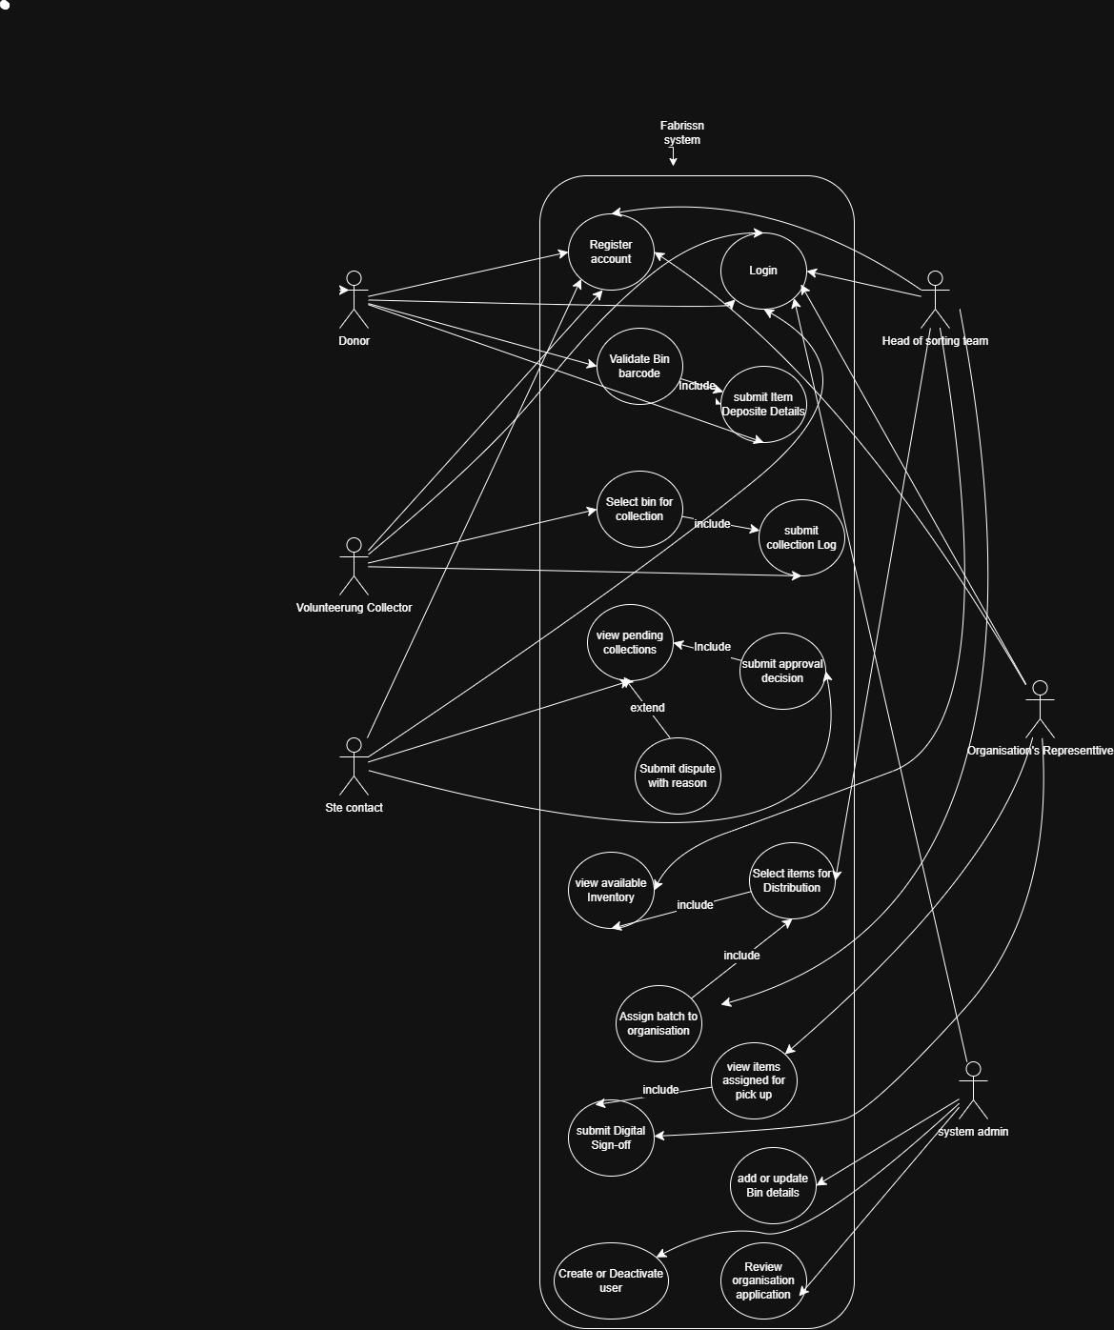

4.3.2 Class Diagram
The class diagram of the FabriScan models the system’s 12 main objects, with their attributes, operations and relationships.
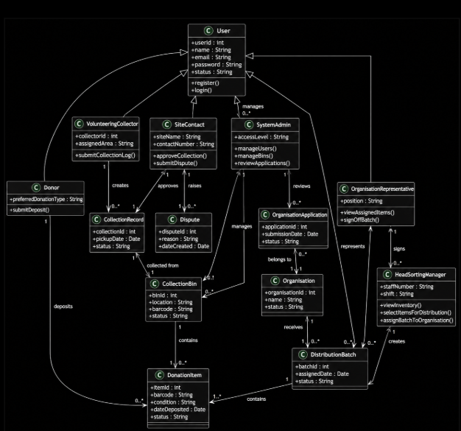

4.3.3 Sequence Diagram
The sequence diagram follows how objects interact show how objects interact over time, visualizing the order of messages that travel throughout FabriScan, thus is effective for showing interactions between system components in the system’s backend.
Donor
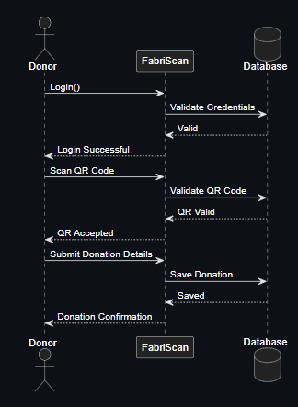

Volunteering Collector
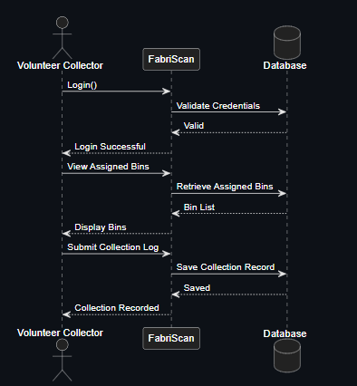

Site Contact
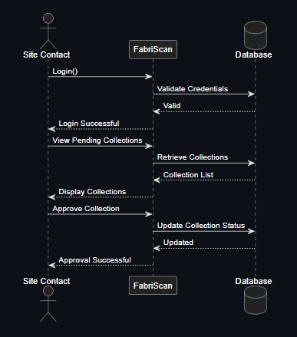

Head Of Sorting Team
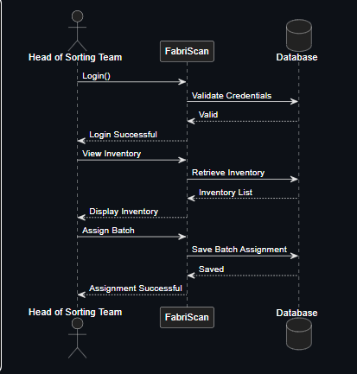

Organization Representative
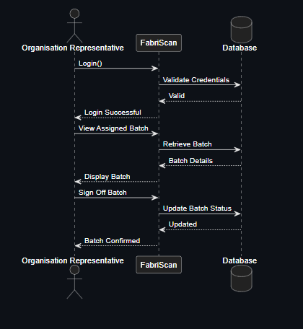

System Admin
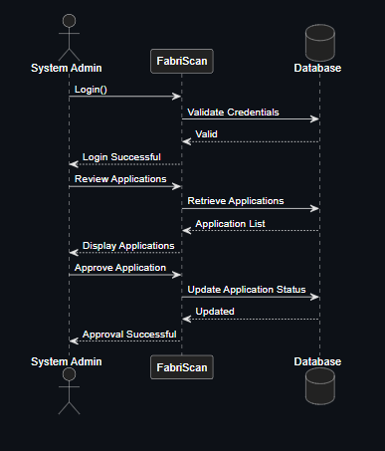

4.3.4 ERD Diagram
The Entity Relationship Diagram outlines the relational structure of FabriScan system’s database across its entities, attributes and relationships. This data is modeled to show the patterns existing among the actors and the system tasks.
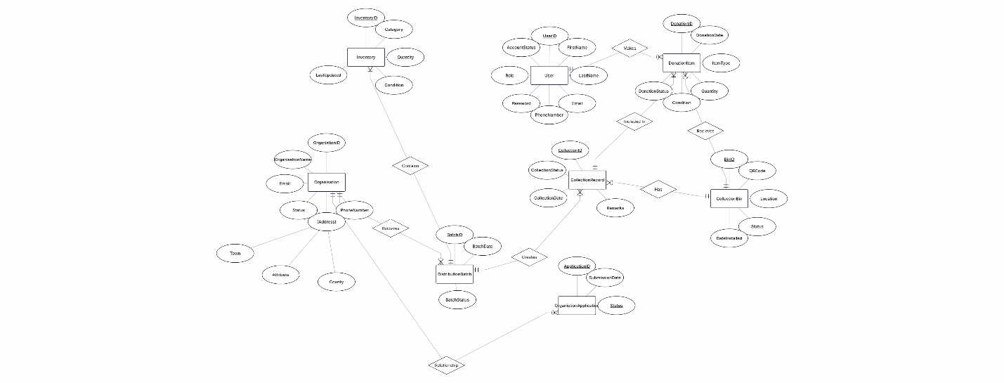

4.3.5 Wireframes
Fabriscan’s wireframe schematic maps out layout, user experience (UX) and the functionality of its web application. The diagrams are to give a visual representation of the system design to the user.
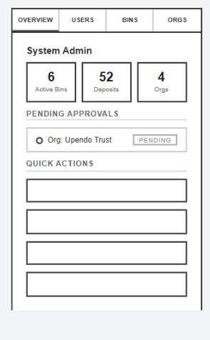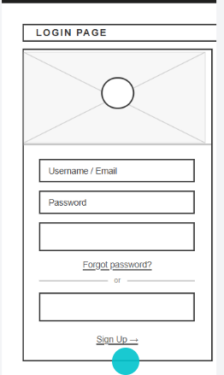

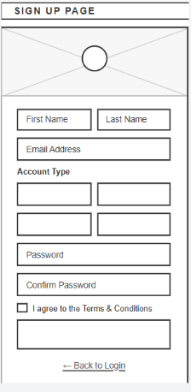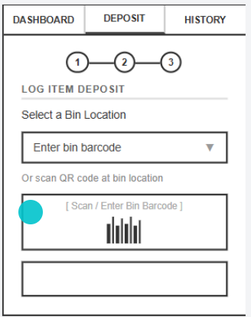

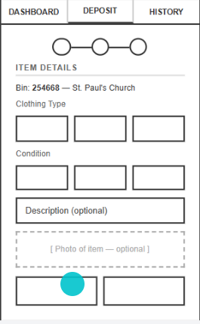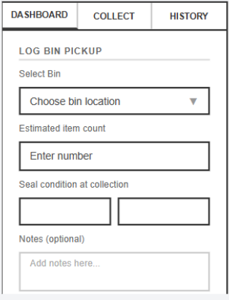

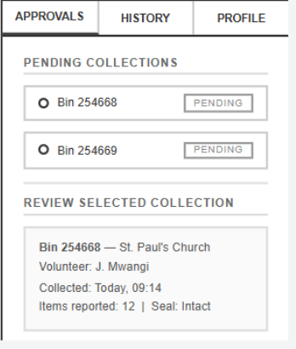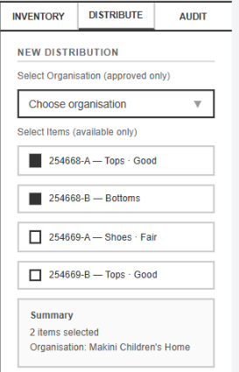
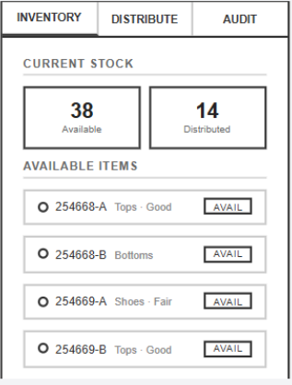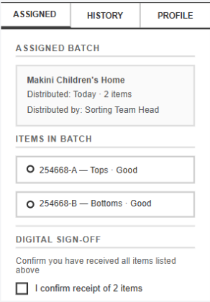

References
Ackerley, T. F. (2025). Commodities, donations, and moral contradictions: An exploratory study of the moral economy of a second-hand charity shop [Master's thesis, Massey University]. Massey Research Online. https://mro.massey.ac.nz/items/a4ea7885-3ab4-42c9-b6a2-d89ca2d1ae8a
Alruwaili, A. F. (2024). Smart blockchain networks: Revolutionising donation tracking in the Web 3.0. Computer Communications, 224, 202–214. https://www.sciencedirect.com/science/article/abs/pii/S0140366424003190
Alturas, B. (2023). Connection between UML use case diagrams and UML class diagrams: A matrix proposal. International Journal of Computer Applications in Technology. https://www.inderscienceonline.com/doi/abs/10.1504/IJCAT.2023.133294
ATRS Corp. (2025, July 10). The benefits of clothing bin donations: A sustainable solution for our planet. https://www.atrscorp.com/the-benefits-of-clothing-bin-donations-a-sustainable-solution-for-our-planet
Bass, J. M. (2022). Requirements. In Agile software engineering skills (pp. 89–109). Springer. https://doi.org/10.1007/978-3-031-05469-3_7
Center for a Digital Future. (2024, June 10). Building blocks. https://www.centerforadigitalfuture.org/blog/60kqfdgb4f8kljqy1j4ujvaqr1bx5y-364pg-bskhw-58gfs-c9t7w-cr3mn-ysa25-rmy2k
Chant, A. (2025, August 14). Beyond bins: Fashion take-back schemes that actually work. Slow Fashion Movement. https://slowfashion.global/2025/08/14/beyond-bins-fashion-take-back-schemes-that-actually-work/
Charity Navigator. (2023). Reflecting on 2023: A year of challenges and growth in philanthropy. https://www.charitynavigator.org/about-us/news-thought-leadership/2023-reflections/
CharityWatch. (2026, February 23). Planet Aid's recycling program, debunked! https://blog.charitywatch.org/planet-aid39s-recycling-program-debunked/
Clothing Collective. (2026, March 14). Clothing's hidden crisis: Participation and public voice. https://www.clothingcollective.org/post/clothing-s-hidden-crisis-participation-and-public-voice
CT.gov. (2025, January 24). Not all charity donation bins are for a good cause. Connecticut Department of Consumer Protection. https://portal.ct.gov/dcp/news-releases-from-the-department-of-consumer-protection/2025-news-releases/not-all-charity-donation-bins-are-for-a-good-cause
Deskera. (2025, December 23). The power of role-based access control in ensuring financial security. https://www.deskera.com/blog/role-based-access-control-power-financial-security/
Diplomatic Courier. (2024, October 16). Tech trends transforming humanitarian aid. https://www.diplomaticourier.com/posts/tech-trends-transforming-humanitarian-aid
Dissanayake, K., & Pal, R. (2023). Sustainability dichotomies of used clothes supply chains: A critical review of key concerns and strategic resources. The International Journal of Logistics Management, 34(7), 75–97. https://doi.org/10.1108/IJLM-10-2022-0410
Eisenbaum, J. (2024, December 10). Charity bins in Houston: Where do your donations go? We tracked it. KPRC. https://www.click2houston.com/news/local/2024/12/09/charity-bins-in-houston-where-do-your-donations-go-we-tracked-it/
Ekechi, C. C., Okeke, C. D., & Adama, H. E. (2024). Enhancing Agile product development with Scrum methodologies: A detailed exploration of implementation practices and benefits. Engineering Science & Technology Journal, 5(5), 1542–1570. https://doi.org/10.51594/estj.v5i5.1108
FundsforNGOs. (2025, January 19). The role of blockchain technology in nonprofit transparency. https://us.fundsforngos.org/articles/the-role-of-blockchain-technology-in-nonprofit-transparency/
Good360. (2025). Corporate product donations. https://good360.org/corporate-partnerships/product-donations/
Good360. (2025). Nonprofit membership. https://good360.org/nonprofit-membership/
Good360. (2025). Understanding Good360's managed programs. https://help.good360.org/2837/kb/article/132070/understanding-managed-programs
Greenhalgh, C., & Montgomery, P. (2024). How trust and relationships impact on the giving decisions of philanthropists. Journal of Philanthropy and Marketing, 29(2), Article e1854. https://doi.org/10.1002/nvsm.1854
Humanium. (2024, September 22). Orphans. https://www.humanium.org/en/orphans/
Inriver. (2025, August 4). Chain of custody software: Why it matters for traceability and compliance. https://www.inriver.com/resources/chain-of-custody-software-traceability-compliance/
International Telecommunication Union. (2023, November 27). New global connectivity data shows growth, but divides persist. https://www.itu.int/en/mediacentre/Pages/PR-2023-11-27-facts-and-figures-measuring-digital-development.aspx
Joint SDG Fund. (2021). Goal 10: Reduced inequalities. https://jointsdgfund.org/sustainable-development-goals/goal-10-reduced-inequalities
Kamran, M., Khan, H. U., Nisar, W., Farooq, M., & Rehman, S. U. (2022). Blockchain-based donations traceability framework. Journal of King Saud University – Computer and Information Sciences. https://doi.org/10.1016/j.jksuci.2022.09.004
Kladana. (2025, July 30). Barcode tracking for enhanced business efficiency and accuracy. https://www.kladana.com/blog/barcoding/barcode-tracking/
Koç, H., Erdoğan, A. M., Barjakly, Y., & Peker, S. (2021). UML diagrams in software engineering research: A systematic literature review. Proceedings, 74(1), 13. https://doi.org/10.3390/proceedings2021074013
Lampoon Magazine. (2023, June 11). A third of all second-hand clothing shipped to Kenya is plastic waste in disguise. https://lampoonmagazine.com/kenya-second-hand-clothing-market-textile-waste-plastic-pollution/
Lowry Solutions. (2025, December 29). Barcode inventory system for real-time asset tracking. https://lowrysolutions.com/solutions/barcode-inventory-control/
Mass.gov. (2022, November). Clothing and textile recovery. https://www.mass.gov/guides/clothing-and-textile-recovery
National Centre for Biotechnology Information. (2023). Socio-ecological drivers of vulnerabilities of children living within orphan homes and the implications for their nurturance care. https://www.ncbi.nlm.nih.gov/pmc/articles/PMC10749914/
Orphan Life Foundation. (2023, November 5). Understanding the impact of clothes donations on orphanages around the world. https://orphanlifefoundation.org/understanding-the-impact-of-clothes-donations-on-orphanages-around-the-world/
PackageX. (2025, December 18). How barcode scanning improves logistics efficiency. https://packagex.io/blog/barcode-scanning-in-logistics
Pathlock. (2026, March 5). Role-based access control (RBAC): A comprehensive guide. https://pathlock.com/blog/role-based-access-control-rbac/
Pressman, R. S., & Maxim, B. R. (2020). Software engineering: A practitioner's approach (9th ed.). McGraw-Hill.
Rachmawati, O. C., Wardani, D. K., Fatihia, W. M., Fariza, A., & Rante, H. (2023). Implementing Agile Scrum methodology in the development of SICITRA mobile application. Jurnal RESTI (Rekayasa Sistem dan Teknologi Informasi), 7(1), 41–50. https://doi.org/10.29207/resti.v7i1.4688
Salesforce. (2025). Good360 routes disaster recovery donations 3x faster with Agentforce. https://www.salesforce.com/customer-stories/good360/
SCIRP. (2023, April 17). Impacts of transparency and traceability on fashion supply chain system. https://www.scirp.org/journal/paperinformation?paperid=124301
Souza, A. D. (2025, June 25). Here's what really happens to your donated clothes. Reader's Digest. https://www.rd.com/article/what-happens-used-clothing-donations/
Supply & Demand Chain Executive. (2024, March 18). From barcodes to QR codes: How technology is changing supply chains. https://www.sdcexec.com/software-technology/software-solutions/article/22890389/bitly-from-barcodes-to-qr-codes-how-technology-is-changing-supply-chains
The Children's Foundation International. (2024, August 2). Understanding orphaned and child poverty: Facts and figures. https://tcfcares.org/orphaned-child-poverty-facts/
Threading Change. (2024, September 12). What really happens to donated clothes? And what can we do with them instead? https://www.threadingchange.org/blog/what-really-happens-to-donated-clothes-and-what-can-we-do-with-them-instead
Threads Monthly. (2024, February 21). 28 statistics about clothing donation and the used/second-hand resale market. https://threadsmonthly.com/clothing-donation-stats/
Thrift Vintage Fashion. (2025, May 6). The donation model is broken: What really happens to donated clothing. https://thriftvintagefashion.com/blogs/news/the-donation-model-is-broken-what-really-happens-to-donated-clothing
UMMA Foundation. (2025). Digital aid: How technology is transforming relief and donor transparency. https://www.ummafoundation.org/post/digital-aid-how-technology-is-transforming-relief-and-donor-transparency
Umbra, A. (2021, April 7). What really happens when I put clothing in a donation bin? Grist. https://grist.org/living/what-really-happens-when-i-put-clothing-in-a-donation-bin/
UNICEF. (2023, September 19). SDG goal 1: No poverty. https://data.unicef.org/sdgs/goal-1-no-poverty/
UN Innovation Network. (2026, February 28). How the Building Blocks blockchain network is transforming humanitarian aid. https://www.uninnovation.network/blog/how-the-building-blocks-blockchain-network-is-transforming-humanitarian-aid
UNOOSA. (2021). Sustainable Development Goal 10: Reduced inequalities. https://www.unoosa.org/oosa/en/ourwork/space4sdgs/sdg10.html
Wandri, R., Fadhilah, M. R., Setiawan, P. R., & Fadhilla, M. (2025). Agile Scrum as a development approach: A case study of web-based school information system design. SISTEMASI, 14(4), 1722. https://doi.org/10.32520/stmsi.v14i4.5273
Wang, B., Lueks, W., Sukaitis, J., Graf Narbel, V., & Troncoso, C. (2023). Not yet another digital ID: Privacy-preserving humanitarian aid distribution. IEEE Symposium on Security and Privacy. https://arxiv.org/pdf/2303.17343
WFP Innovation. (2025, May). Building blocks. https://innovation.wfp.org/project/building-blocks
World Journal of Advanced Research and Reviews. (2026). Financial accountability and governance in nonprofit organisations. https://wjarr.com/sites/default/files/fulltext_pdf/WJARR-2026-0710.pdf
Zhang, Z., Zhuge, X., Li, X., Evans, R., & Liu, A. (2022). An object-oriented approach to the modular design of mechatronic systems. IEEE Transactions on Engineering Management, 71. https://ieeexplore.ieee.org/document/9844439

